Arkansas Stroke Assistance Spring 2016
Through Virtual Emergency Support

The Penumbra
Welcome to the Spring 2016 issue of The Penumbra
Welcome to the Spring 2016 issue of the quarterly newsletter for the ARSAVES program! As always, our wish with each issue is that the information presented in each issue, you will find informative, entertaining and illustrative of the dedication of those involved in the program.
In this issue we will give you an update on our EMS Training Initiative spearheaded by our own Tim Vandiver, as well as information on a new initiative focusing on Law Enforcement targeting interactions of officers/deputies with those suffering from diabetic issues or current/residual stroke issues. We also have information spotlighting new items for Community education events from Lauren Scott plus a short piece from Ben Boulden about the power of using patient stories as teaching tools! We also have a little “fun time” item submitted by Conelia Williamson. We hope you enjoy.
Move to the side! EMS education is running “hot”! By Tim Vandiver
Update on EMS outreach. Since January of this year we have been doing a big push to do in-service training for the EMS community. We have completed presentations for many EMS agencies, Fire Departments (paid and volunteer), EMS conferences and EMS training sites such as National Park College, SACC and UAMS. We are providing education including the topics of new stroke treatments, the ARSAVES program and the upcoming Acute Stroke Ready Hospital designation process.
So far we have reached over 500 EMS providers face to face with more presentations scheduled over the next three months. We are scheduled to present to the Arkansas Ambulance Association in April. May will also be busy. The Little Rock Fire Department has been scheduled for 8 days of training in May to educate all 480 EMT’s on their department. We will also be teaching Med Tech EMS in Conway County in May and the Salem Fire Department in Saline County in June.
ARSAVES staff will also be attending the AEMTA (Arkansas EMT Association) Conference August 3-7 in Hot Springs with the Mega Brain exhibit. Tim will be doing a breakout session during the conference presenting the power point program that he has been teaching around the state. This conference is attended by more than 700 EMS personnel. Our efforts will continue in reaching the EMS community over the next year and through the designation process. Hopefully this will ensure getting the right patient to the right hospital in the shortest amount of time. The work continues….

Never Judge a Book by its Cover! By David Wollard
At last year’s AR SAVES Conference, we were pleased to have Mary Pinzon from Integris, Oklahoma as a speaker. She discussed her efforts at educating Law Enforcement in Oklahoma on the subject of interaction with individuals dealing with a diabetic episode of some type, TBI (Traumatic Brain Injury), Aphasia, and Stroke. Her program has met with great success in Oklahoma. After meeting with Mary and discussion, it was decided that such an initiative was needed here in Arkansas. Improper interaction or ineffective interaction between Law Enforcement over the years has led to injury of the individual being stopped and significant litigation for departments. There have been cases litigated in many states including right here in Arkansas.
A presentation covering Diabetes, Stroke and the AR SAVES program has been put together which offers Law Enforcement personnel 3 hours of Educational Credit, and is accredited through the Arkansas Commission on Law Enforcement Standards and Training (CLEST). As a CLEST certified instructor, I will be traveling around the state to do the classes for any agency requesting. The training is completely free to all departments. More than one class can be done in a day or multiple classes over several days/dates for larger departments. Areas where several smaller departments exist can come together in once venue to undergo the training.
We held the first training in Sheridan, AR on April 15th with their PD, Sheriff’s department and also personnel from the Detention Center there. The classes were well received and well attended. A special “thank you” to Conelia Williamson for facilitating the class (She “knows” people there). Classes are also scheduled for Benton in June. I am also awaiting firm dates from several other agencies in the state. If you know any agency (police or Sheriff, State Police, Parks and Game, etc.), or someone at an agency who would benefit from this training, please pass my contact information along. I have sent out fliers in the past and have put one here as well. As some agencies are located/posted in very rural areas of the state, it is essential they have proper training. My work cell is 501-413-6596.

Patient Stories as Powerful Teaching Tools by Ben Boulden
Educating the public about almost anything works best when it’s done with the power of good storytelling, and the stories of AR SAVES patients are powerful ones to tell.
Recently, I interviewed a man in his twenties who had a stroke and quickly called 911. He recognized his symptoms as the signs of stroke because he had read the FAST mnemonic on a sign or website. In less than an hour and at an AR SAVES partner hospital, he got the treatment he needed and avoided permanent neurological deficits.
His story brought into sharper focus for me the value of what I have tried to do when writing for AR SAVES. From the stories of stroke survivors, readers can learn the importance of recognizing symptoms and of timely treatment in a way that becomes strongly personal.
I’ve seen a retiree who was able to throw a Strike Out Stroke pitch six days after his stroke. I’ve talked to a young father and family breadwinner who was able to return to work less than a month after his stroke. I’ve heard a young woman speak about how AR SAVES helped her to keep being a mother to her children.
Besides achieving the most important goal of returning men and women to healthy, active life, AR SAVES is helping health care and social support systems avoid the incredible costs of caring for individuals who otherwise might be physically disabled for the rest of their lives. Just imagine how long that twenty-something stroke survivor might have been on disability without the intervention of AR SAVES.
To make those stories happen, people need to know what to do. The absolute necessity of timely treatment of stroke is a lesson most effectively taught through the stories of survivors who received it. That’s why it has been such a rewarding experience writing for AR SAVES and being a part of getting that message out.

News You Can Use by Lauren Scott

Educational Materials from Genentech
At the Nurse Facilitators Retreat, questions were asked in regards to the educational materials offered from Genentech. A great website for those is: http://www.strokeawareness.com/ if you need specific educational materials, contact your health educator. For any clinical materials, contact your outreach nurse.
AR SAVES Website
Our website is undergoing major reconstruction! Please be patient with us during this process. If at any time, any forms or additional information is needed and is no longer available, please contact Lauren Scott at lbscott@uams.edu or 501-410-4278 for assistance.

AR SAVES Promotional Items
I am happy to announce we have some great, new promotional items arrive!! Some examples are Post-it notes, Frisbees, bookmarks and stickers. Many requests have been received for promotional items geared towards children. We have some now! We will have our promotional items at the upcoming conference, but only a limited amount. Contact your community health educator for larger amounts.

We also have a new design and new colors of our magnets! I have included one of our new colors below as an example. (The actual color looks a little different in person compared to what shows on the computer).
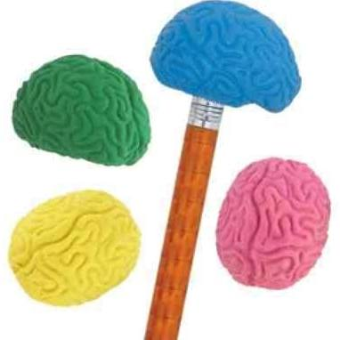
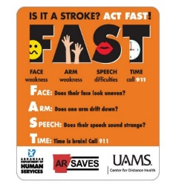

These brain shaped pencil toppers have been a HUGE hit!

Mega Brain Link
Below is the link to complete a request for the Mega Brain at your outreach function. Once you submit your request, it will go before a committee for approval. You will be notified via email once a decision is made regarding your request. Please keep in mind there will be a few factors the committee has to regard, for instance if there are two requests for the same date/time. The size of the event, target audience, location, etc. will be taken into consideration. A few reminders as well: if the event is outdoors, weather is a huge factor. If there is any type of precipitation (even mist), the Mega Brain will NOT be set up and inflated. The Mega Brain is very large and requires a minimum of six (the more the better) volunteers to assist with set up/break down and manning it. Crowd control is necessary! If at any time you have questions, please contact your health educator.
http://arkansaselink.com/the-mega-brain-has-become-a-powerful-exhibit-in-educating-the-public-about-the-brain-and-stroke-it-will-be-an-effective-tool-at-your-community-events/

The Mega Brain requests calendar fills up quickly! So submit your request as soon as possible!

If you haven’t had the opportunity to see the Mega Brain, we will have it at the upcoming conference!

Monthly Data is DUE by the 15th of each month!

AR SAVES Monthly Report
Just another reminder that your site is required to submit a monthly report, and it is due by the 15th of each month! When our quarterly reports are due, it’s imperative we have all information in as soon as possible in order to prevent any delays!! If you have any questions regarding the data portion, contact your outreach nurse. In regards to community outreach: Every month we require a minimum of one ACTIVE event and a minimum of one PASSIVE event. If more than one Active event is done, a Passive event is not required, although highly recommended. Please report ALL events on your report-whether it’s one of each or 10 of each. The more education the better! If you are struggling for any reason to get your outreach complete, contact your health educator for assistance. Also, when reporting, be as specific as possible. If materials are placed in a doctor’s office-how many were placed, what materials were placed, and what is the name of the clinic/who is/are the doctor(s) at that office? And again, if acronyms are used, please let us know what it stands for! Any questions regarding reporting community outreach, contact your health educator.

As discussed at the Nurse Facilitators Retreat, the health education team will create a new list of outreach ideas. If you have any that you feel are unique or creative, please share with us and we will add them to the list.

How about some fun? By Conelia Williamson

We have a fun puzzle submitted by Conelia. I was “searching” for the right words to put here, but I’ll just let you find your own on the puzzle below! Also a great educational tool for young and old alike. Have fun!

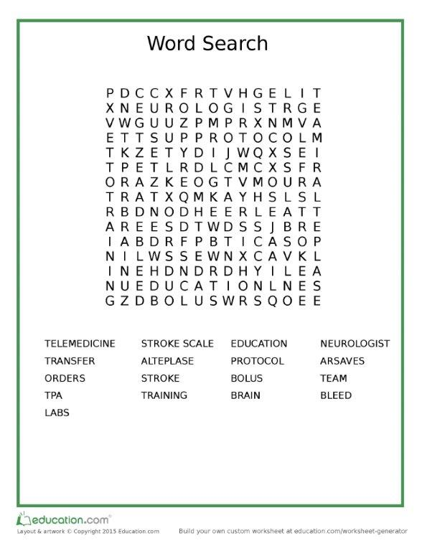

Reminders: Please ensure that your monthly mocks are completed as well as your monthly data submission. Data is to be received by ARSAVES no later than the 15th of each month, covering the previous month.

If you have something you would like to submit for the next quarterly newsletter, send to wollarddavidl@uams.edu for consideration.

See you next time!

