Arkansas Stroke Assistance Summer/Fall 2016

Through Virtual Emergency Support

*The Penumbra*

*Welcome to the Penumbra*

Welcome to another issue of the quarterly newsletter for the ARSAVES program! As always, our wish with each issue is that the information presented in each issue, you will find informative, entertaining and illustrative of the dedication of those involved in the program.

In this issue we have an update on our Law Enforcement Training Initiative targeting interactions of officers/deputies with those suffering from diabetic issues or current/residual stroke issues. We have a very informative piece written by Dr. Onteddu on Coumadin and the stroke patient. We have a brief summary about the 2016 Nurse Facilitator Retreat. We also have information spotlighting new items for Community education events from Lauren Scott. We also have a more “fun time” item submitted by Conelia Williamson for Conelia’s Corner. We hope you enjoy.

*What about patients on Coumadin, and stroke? By Sanjeeva Reddy Onteddu*

What are treatment options when patients are getting Coumadin and they still have a stroke?

Studies have shown that getting Activase with an INR of <1.7 in the first 3 hours since symptom onset has been safe without any additional risk of symptomatic Intra cerebral hemorrhage.

What to do with patients who have INR >1.7, there are studies which show that Activase can increase the risk of Intracerebral hemorrhage with INR >1.7, so Activase if contraindicated.

There are rare instances where patients getting correction of their INR and then getting Activase has been reported and it is rare. AHA/ASA does not recommend treatment with Activase if patient has INR >1.7.  As it takes time for the reversal of coagulopathy with Fresh frozen Plasma it is not advisable to correct their coagulopathy.

If you encounter patients whose INR is >1.7 and still having a devastating stroke, always consider additional procedure like intra-arterial Activase or neuro thrombectomy which are safer.

What about patients who are taking Coumadin and present within 3-4.5 hours since symptom onset? There is limited data on how the bleeding risks are with these patients and AHA/ASA current updated guidelines do not recommend Activase irrespective of INR if they are on Coumadin, and have been taking Coumadin.

*Scientific Rationale for the Inclusion and Exclusion Criteria for Intravenous Alteplase in Acute Ischemic Stroke: A Statement for Healthcare Professionals From the American Heart Association/American Stroke Association. Stroke. 2016;47(2):581-641.*

*Never Judge a Book by its Cover! (Part II) By David Wollard*

The efforts to educate Law Enforcement are proceeding. Classes have been done in certain areas with more on the way. To date we have taught 92 Law Enforcement Officers across the state. Departments taught include Sheridan, Benton, and the Arkansas State Police. I will be offering the class for the DeWitt PD in October and scheduling a class in the Ft. Smith area soon as well. If you all have any contacts in Law Enforcement, please do not hesitate to forward the flier here to them or whoever oversees education and training. It is a free class and yields 3 hours of education credit through the state standards for law enforcement. As some agencies are located/posted in very rural areas of the state, it is essential they have proper training. My work cell is 501-413-6596.



*Nurse Facilitator Retreat 2016 by David Wollard*

The 2016 Nurse Facilitator Retreat went off without a hitch. Held at the beautiful Rockefeller Center, the serene surroundings lent a relaxed and calming atmosphere in contrast to the normal frantic pace of our usual lives. Almost all of our sites were represented there and we want to thank all who were able to attend. Hopefully we can achieve 100% next year.

Great discussion was had with issues, questions and ideas brought up by the attendees. Interaction between sites was one of the goals and we hope that was achieved to a greater degree and hope it continues with each successive year we have the Retreat. Topics discussed included monthly data collection and need for refinement, mocks and processes, conduct of live AR SAVES calls, contracts, site training/re-training, advanced “Super User” training, evidenced based practices, input for our quarterly newsletter and the designation process.

Several great ideas were presented by the sites and created areas for future discussion as we strive to make the AR SAVES experience even better.

*News You Can Use by Lauren Scott*

Educational Materials from Genentech

At the Nurse Facilitators Retreat, questions were asked in regards to the educational materials offered from Genentech. A great website for those is: <http://www.strokeawareness.com/> if you need specific educational materials, contact your health educator. For any clinical materials, contact your outreach nurse.

AR SAVES Website

Our website reconstruction continues. You may now find the individual sections for the Nurse Facilitator Packet and the “Red” Binders on our site under the link at the left of the Home Page, <http://arsaves.uams.edu/ar-saves-healthcare-professionals/>. Please continue to be patient with us during this process. If at any time, any forms or additional information is needed and is no longer available, please contact Lauren Scott at [lbscott@uams.edu](mailto:lbscott@uams.edu) or 501-410-4278 for assistance.

AR SAVES Promotional Items

I am happy to announce we have some great, new promotional items arrive!! Some examples are Post-it notes, Frisbees, bookmarks and stickers. Many requests have been received for promotional items geared towards children. We have some now! We will have our promotional items at the upcoming conference, but only a limited amount. Contact your community health educator for larger amounts.

We also have a new design and new colors of our magnets! I have included one of our new colors below as an example. (The actual color looks a little different in person compared to what shows on the computer).

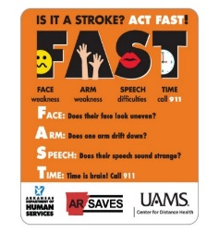[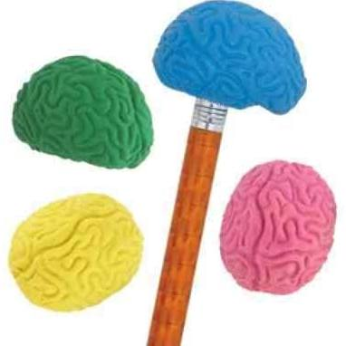](http://www.google.com/aclk?sa=L&ai=CFJiEdnwiV_b3IoXY-QP16ILIDIn1u7AH2bbRvMcB2efQt4YFCAkQBCDezc8eKAxgya69hsCj2BXIAQeqBCZP0O2tzi5RxiBTGD-I_7KlH2k6OIOayLMqU709eC-PwVrrkSd_hsAFBaAGJoAH24COFZAHA6gHpr4b2AcB4BLKtoWJ_oCtzyk&sig=AOD64_2QYdS9VHmJHRd6yxGQbgMEKOOsOQ&adurl=http://rover.ebay.com/rover/1/711-117182-37290-0/2?mtid%3D1588%26kwid%3D1%26crlp%3D53601919689_324272%26itemid%3D172029062416%26targetid%3D173525971929%26rpc%3D0.14%26rpc_upld_id%3D69172%26device%3Dc%26mpre%3Dhttp://www.ebay.com/ulk/itm/like/172029062416?lpid%3D82%26chn%3Dps%26adtype%3Dpla%26googleloc%3D9025851%26poi%3D9025859%26campaignid%3D239125209%26adgroupid%3D14978428809%26rlsatarget%3Dpla-173525971929&ctype=5&clui=14&rct=j&q=&ved=0ahUKEwjysp-9n7LMAhVS2GMKHfoeD74QqCsIJA&ei=dnwiV_KfIdKwjwP6vbzwCw)

**These brain shaped pencil toppers have been a HUGE hit!**

Mega Brain Link

Below is the link to complete a request for the Mega Brain at your outreach function. Once you submit your request, it will go before a committee for approval. You will be notified via email once a decision is made regarding your request. Please keep in mind there will be a few factors the committee has to regard, for instance if there are two requests for the same date/time. The size of the event, target audience, location, etc. will be taken into consideration. A few reminders as well: if the event is outdoors, weather is a huge factor. If there is any type of precipitation (even mist), the Mega Brain will NOT be set up and inflated. The Mega Brain is very large and requires a minimum of six (the more the better) volunteers to assist with set up/break down and manning it. Crowd control is necessary! If at any time you have questions, please contact your health educator.

<http://arkansaselink.com/the-mega-brain-has-become-a-powerful-exhibit-in-educating-the-public-about-the-brain-and-stroke-it-will-be-an-effective-tool-at-your-community-events/>

The Mega Brain requests calendar fills up quickly! So submit your request as soon as possible!

*If you haven’t had the opportunity to see the Mega Brain, we will have it at the upcoming conference!*



**Monthly Data is DUE by the 15th of each month!**

AR SAVES Monthly Report

Just another reminder that your site is ***required*** to submit a monthly report, and it is ***due by the 15th of each month***! When our quarterly reports are due, it’s imperative we have all information in as soon as possible in order to prevent any delays!! If you have any questions regarding the data portion, contact your outreach nurse. In regards to community outreach: Every month we require a minimum of one ACTIVE event and a minimum of one PASSIVE event. If more than one Active event is done, a Passive event is not required, although highly recommended. Please report ALL events on your report-whether it’s one of each or 10 of each. The more education the better! If you are struggling for any reason to get your outreach complete, contact your health educator for assistance. Also, when reporting, be as specific as possible. If materials are placed in a doctor’s office-how many were placed, what materials were placed, and what is the name of the clinic/who is/are the doctor(s) at that office? And again, if acronyms are used, please let us know what it stands for! Any questions regarding reporting community outreach, contact your health educator.

As discussed at the Nurse Facilitators Retreat, the health education team will create a new list of outreach ideas. If you have any that you feel are unique or creative, please share with us and we will add them to the list.

*More Fun from Conelia’s Corner! By Conelia Williamson*

We have a fun puzzle submitted by Conelia. I was “searching” for the right words to put here, but I’ll just let you find your own on the puzzle below! Also a great educational tool for young and old alike. Have fun!

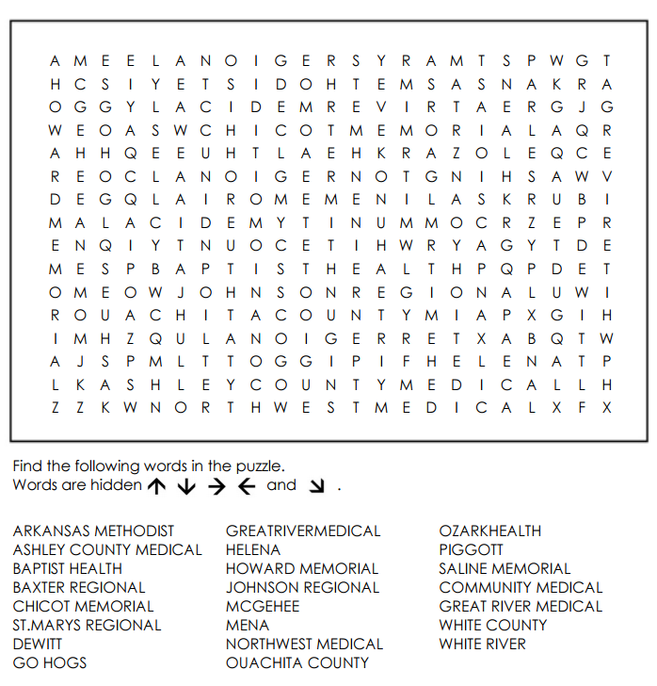

AND FINALLY!.........  
  
CAPTION THIS!!

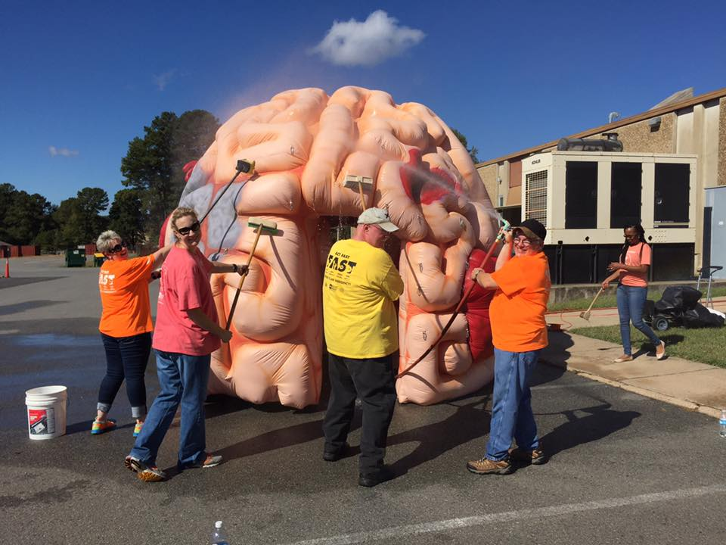

The funniest caption will be chosen and shared at the next All-Site’s Meeting!

***Reminders****: Please ensure that your monthly mocks are completed as well as your monthly data submission. Data is to be received by ARSAVES no later than the 15th of each month, covering the previous month.*

***Remember****, if you have something you would like to submit for the next quarterly newsletter, send to* [*wollarddavidl@uams.edu*](mailto:wollarddavidl@uams.edu) *for consideration. We value your input!!*

*See you next time!*